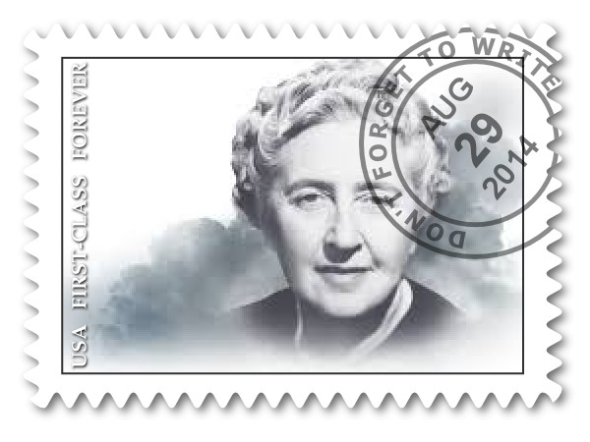
Agatha Christie

October 1920
Dear Diary, today I released my first novel, The Mysterious Affair at Styles, it stars a detective named Hercule Poirot. I’m very excited and worried to see if the people like my book. I think that it will get very good ratings. I began writing in the middle of World War 1. The dedication to my book is to my mother. Im thinking about making this book into a series. I think it would be a most wonderful series. Im very nervous about the whole thing, as I said earlier. I shall write tomorrow and we shall see how good this book truly is. We shall see.
Until next time,
Agatha Christie

December 3, 1926
Today I disappeared. Or well I disappeared from everyone else. I left because I was very sad because my Husband wanted a divorce. I instantly ran away. I am so sad. I don’t know if I will or every write again, I might not even come out of hiding, I’m too sad. I feel I may never even write in my diary. If not I must say goodbye. I have had a great time sharing my life with you. Goodbye for now or not.
Sincerely,
Agatha Christie

October 1930
Dear Diary, today I released a new series with a lady named Miss Jane Marple. The book is called, Murder at the Vicarage. My series Hercule Poirot is doing magnificent so I believe that Miss Jane Marple is going to do just as good or even better. Let’s hope so. Now that I said it I definitely think Miss Jane Marple will do magnificent. This is my first book with the character Miss Jane Marple. I am going to be so happy when I go to bed later in the night. It’s been dreadful for the last couple of months with so much stress and work to get my book ready to be published I’ve barley gotten any sleep. Now I may sleep peacefully. I might just take the whole day off tomorrow. Well I might not right tomorrow so whenever I write in here again I will tell you what has happened and how my book is going.
Until next time,
Agatha Christie

Agatha

Skinny, curly hair,
Perky, joyful, imaginative, lovely
Who feels very happy
Who needs a good mystery
Who likes to write
Who fears no sales
Who would like to see herself succeed
Who wishes everyone would like her books
Who is good at writing
Friend of Hercule Poirot, Miss Jane Marple, Tommy, and Tuppence.
Daughter of Clarissa Margaret Boehmer
Resident of the afterlife
Christie

Greenway House
South Devin, England
November 23, 1929
Dear Graham Greene,
I have just thought of a new character for my new series her name is Miss Jane Marple. She’s far more fun, really, and there are plenty of grandmothers and aunts like her about, who are splendid and natural detectives when it comes to observing human nature.
When you first start to think out a book, the nicest thing to do is go for a nice long walk somewhere. My first book was written walking about Dartmoor when I had a fortnight’s holiday from the hospital that I was working in.
I do think Miss Jane Marple will be splendid. I hope all is going well with you. Maybe one day soon we can sit and have a nice cup of tea. Until then I shall keep sending you letters.
Sincerely,
Agatha

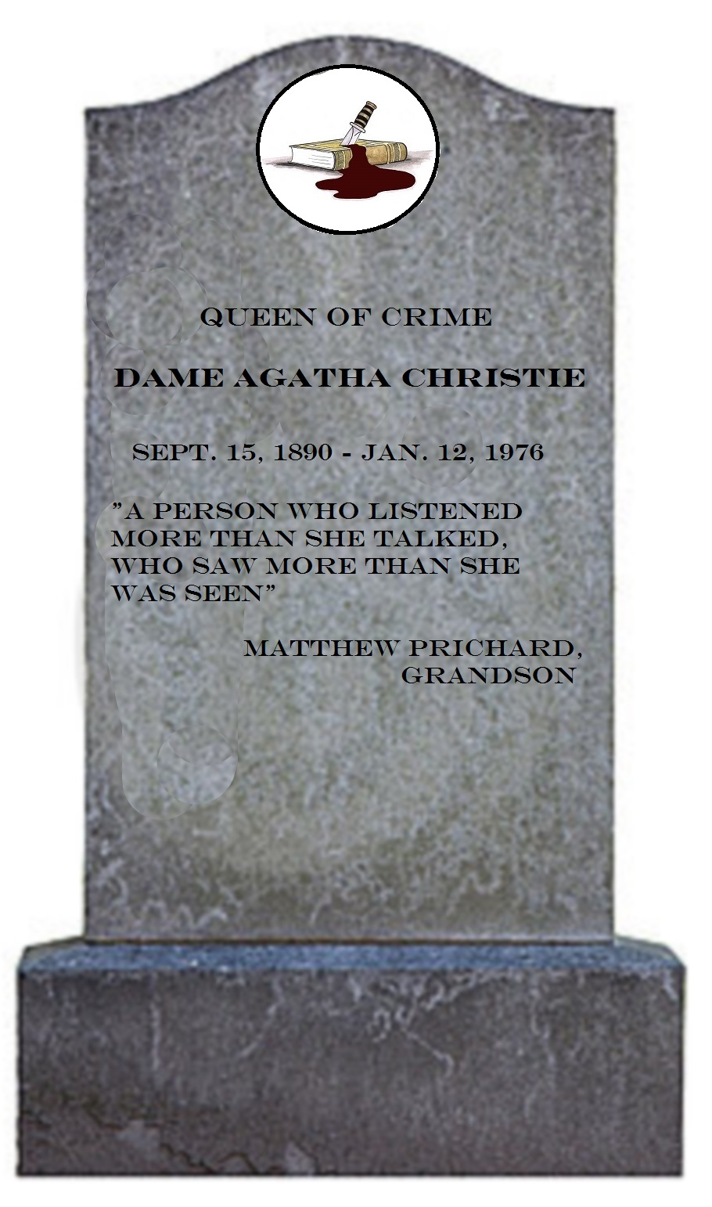

Works Cited

Acocella, Joan. "Queen of Crime." The New Yorker 16 Aug. 2010: 82. Literature Resource Center. Web. 8 Sept. 2014.
"Dame Agatha Christie." Britannica. Web. 7 Sept. 2014.
"Mathew on Christie." Agatha Christie. Web. 7 Sept. 2014.
Wynne, Nancy. An Agatha Christie Chronology. New York, New York: Division of Charter Communications, 0. 266. Print.

